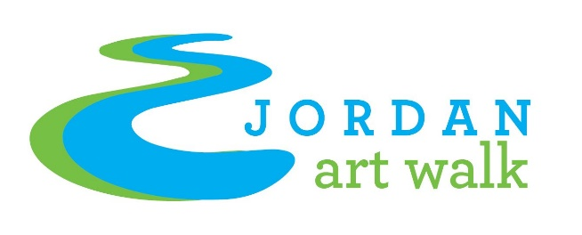

Call to Artists
Project Summary: Jordan Art Walk
You are invited to submit a sculpture for placement in the Jordan Art Walk exhibit in East Jordan, Charlevoix County, Michigan. Our goal is to integrate works of art into our city’s abundant natural environment that will engage and resonate with our citizens and visitors. Project Description: “Exploring Nature Through Art”
Sculptures will be located along a route connecting the east and west sides of East Jordan. An attractive recently completed walkway, “Joining Jordan,” connects the two parts of the city over the bridge where the Jordan River joins Lake Charlevoix. An accessible walking trail into the Jordan Valley will soon be linked. These projects have added access to pedestrian, bicycle and motorized vehicle traffic. Twenty sculptures are now placed on city property along this pathway and into the downtown area. The walk is currently anchored by a city park on the west side river estuary and by the municipal harbor/concert shell on the east side. We will add 6-7 additional sculptures in 2024.
Now in our fourth year, this is a collaborative project of the City of East Jordan, the East Jordan Area Chamber of Commerce, the Friends of the Jordan River, the Jordan River Arts Council, and Active Recovery Physical Therapy and Sports Medicine. Please go to www.jordanartwalk.org for further information about the walk.

Budget Description:
The sculptures will be in place for 3 years and if the artist chooses to offer their sculpture for sale, a 20% commission is paid to the committee. If sold, the work of art will remain in place until the end of the three year time period or be replaced with another sculpture by the artist with approval of the committee. There is a stipend of $600 for the artists selected for the exhibit. Concrete pads will be provided to fit the works of art. Artists will be responsible for transporting, installing and de-installing the art work. Some exemptions may apply.
Timeline:
Please submit up to 3 entries digitally by April 15, 2024 to the East Jordan Area Chamber of Commerce (info@ejchamber.org) for jurying. Multiple views of each sculpture may be submitted. Artists will be notified of acceptance by April 30th and installations will take place by June 1st.
Requirements:
A jurying committee of local artists and citizens will make selections based on the following criteria:
(1). Artistic merit of the original work.
(2). Art work must be of a safe design, construction, and have the ability to be safely secured.
(3). Art work must be durable for outside four-season display.
(4). Art must be compatible with the unique setting of the East Jordan environs.
(5). A completed Information sheet shall accompany photographs of each piece submitted (please see attached).
(6). An artist resume shall accompany the application.

Application

- Title_____________________________________
- Artist Statement_________________________________________
______________________________________________________
______________________________________________________
______________________________________________________
______________________________________________________
______________________________________________________
______________________________________________________
- Dimensions_____________________________________________
- Base Size Requirement:____________________________________
- Materials_______________________________________________
- Fabrication______________________________________________
- Price___________________

Artist Information

Name______________________________________________________________
Mailing Address_____________________________________________________
Email______________________________________________________________
Phone(s) ___________________________________________________________
Website____________________________________________________________
Please attach a resume.

